Access website using Domain name

1. Launch EC2 instance (Install httpd)

* Select VPC and subnet

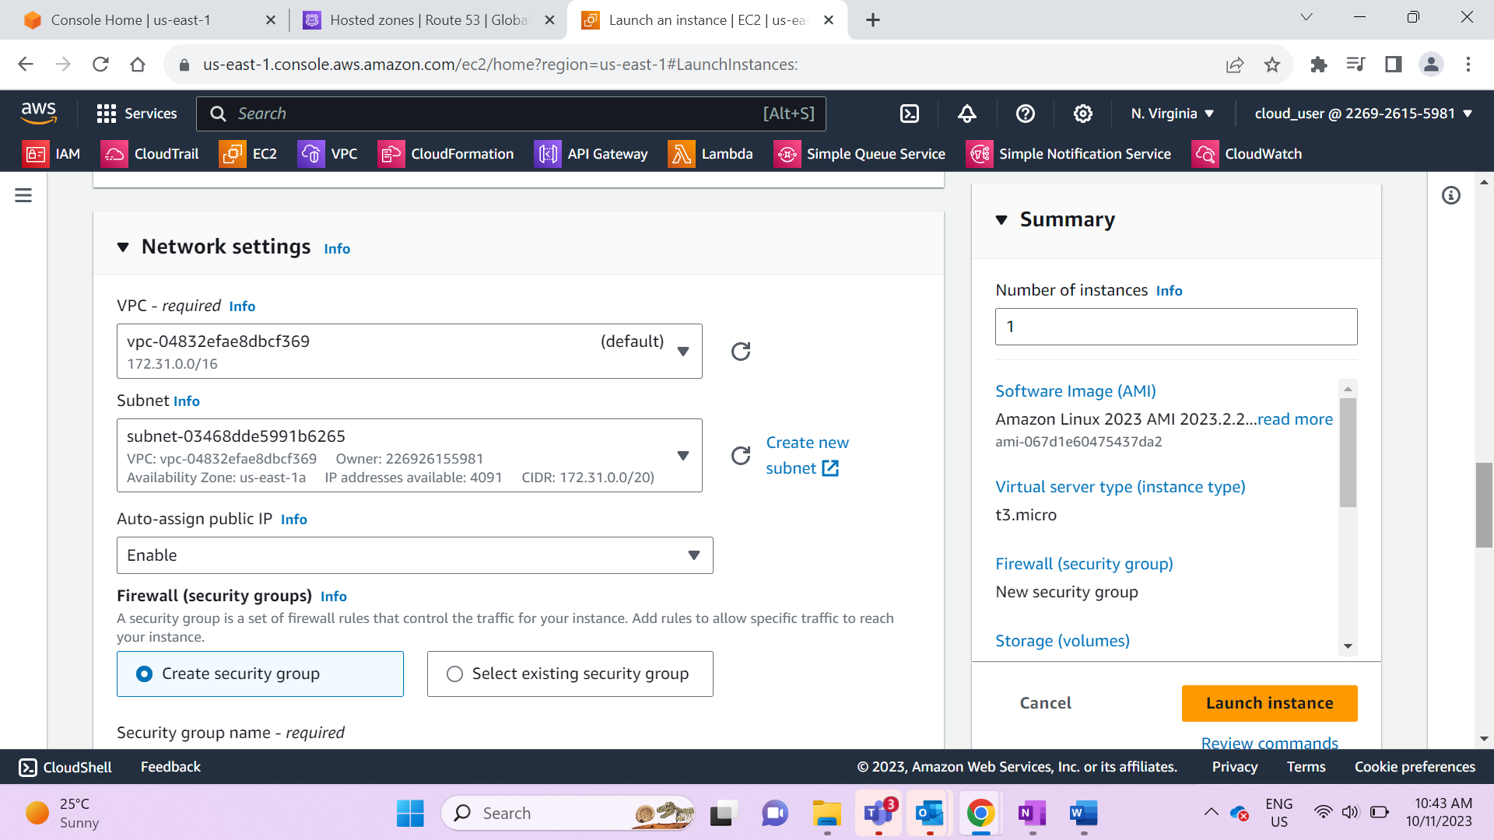

* Select Security group as http

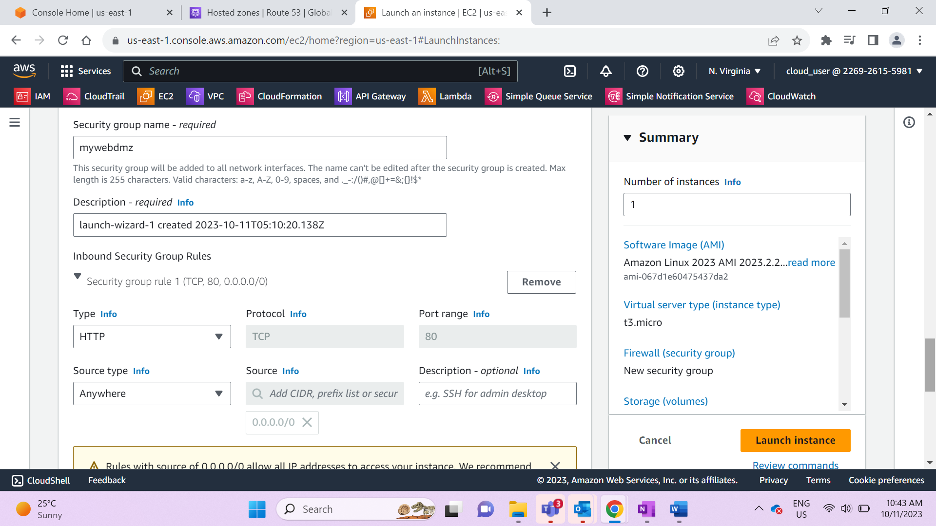

* Install httpd as bootstrap when server is started

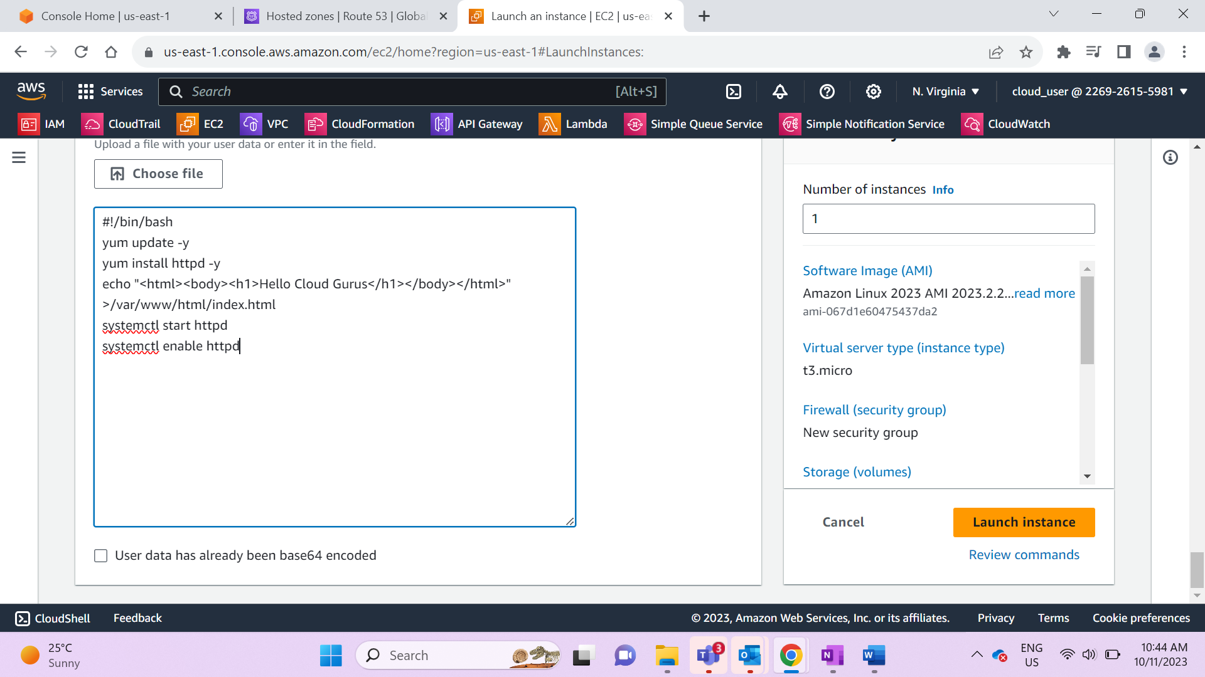

1. Create Application Load Balancer

* Select the security group & VPC created during EC2
* Configure EC2 instance as target

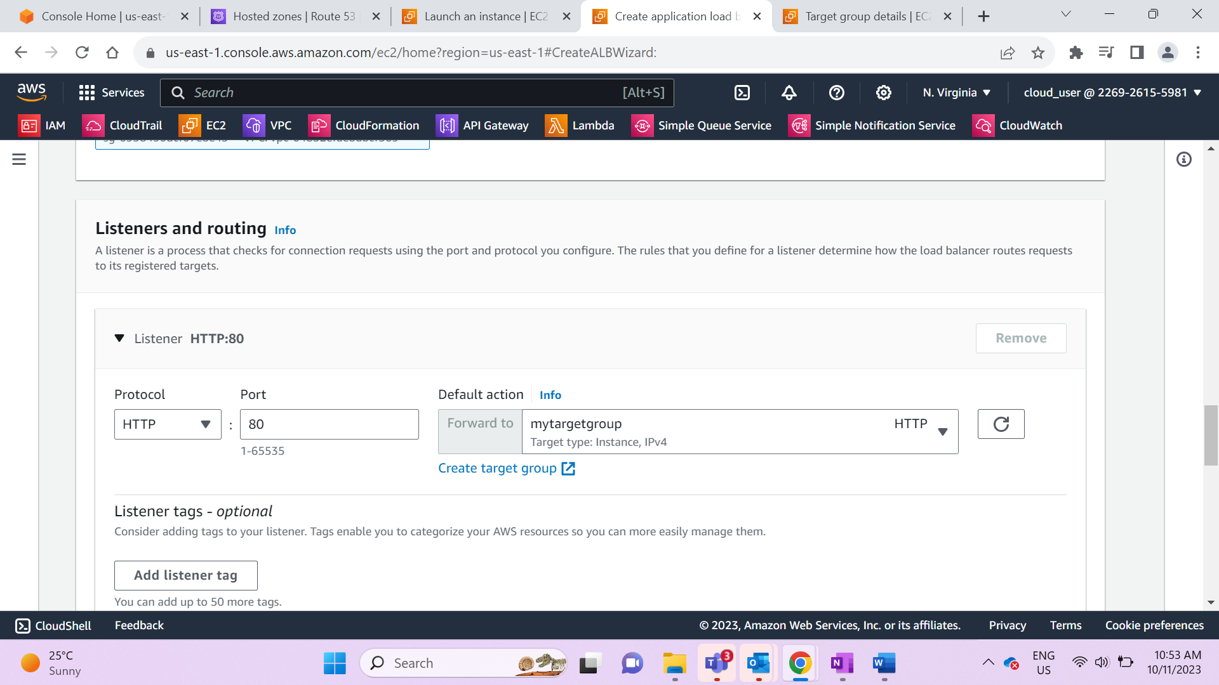

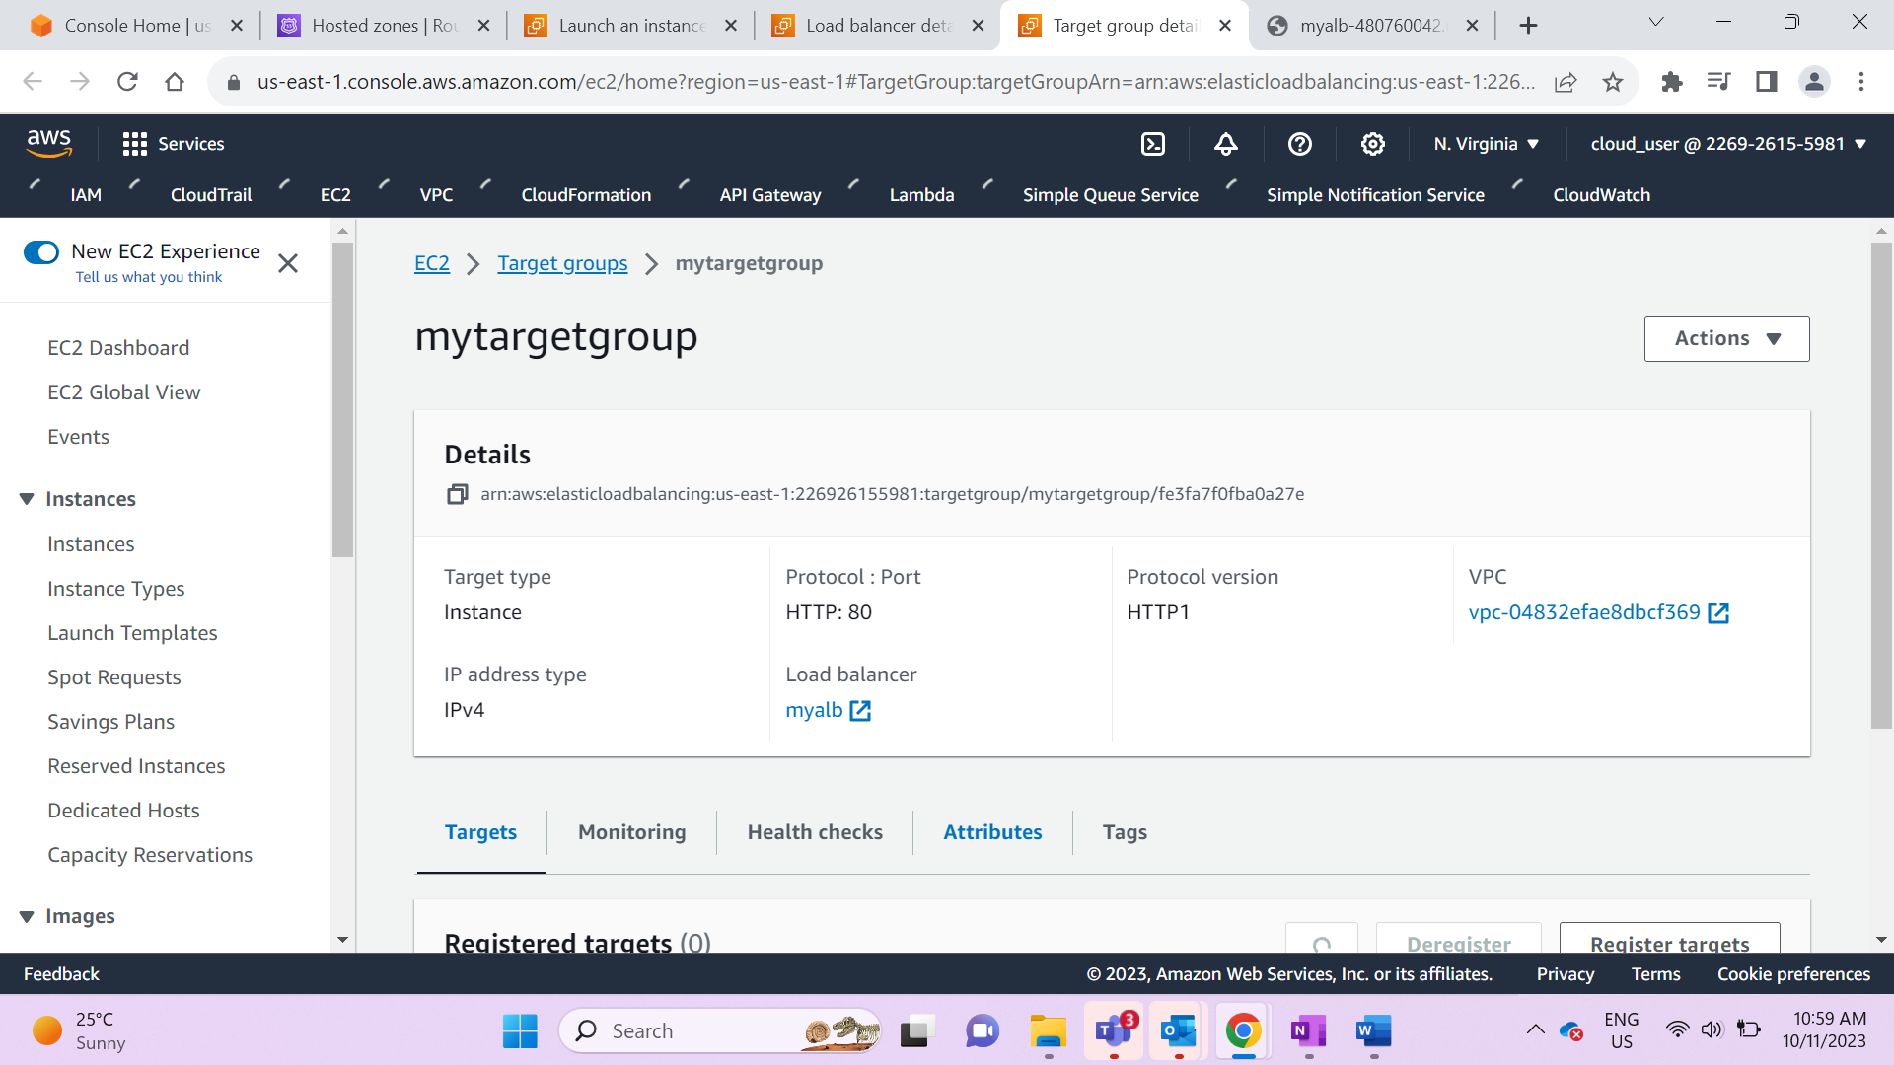

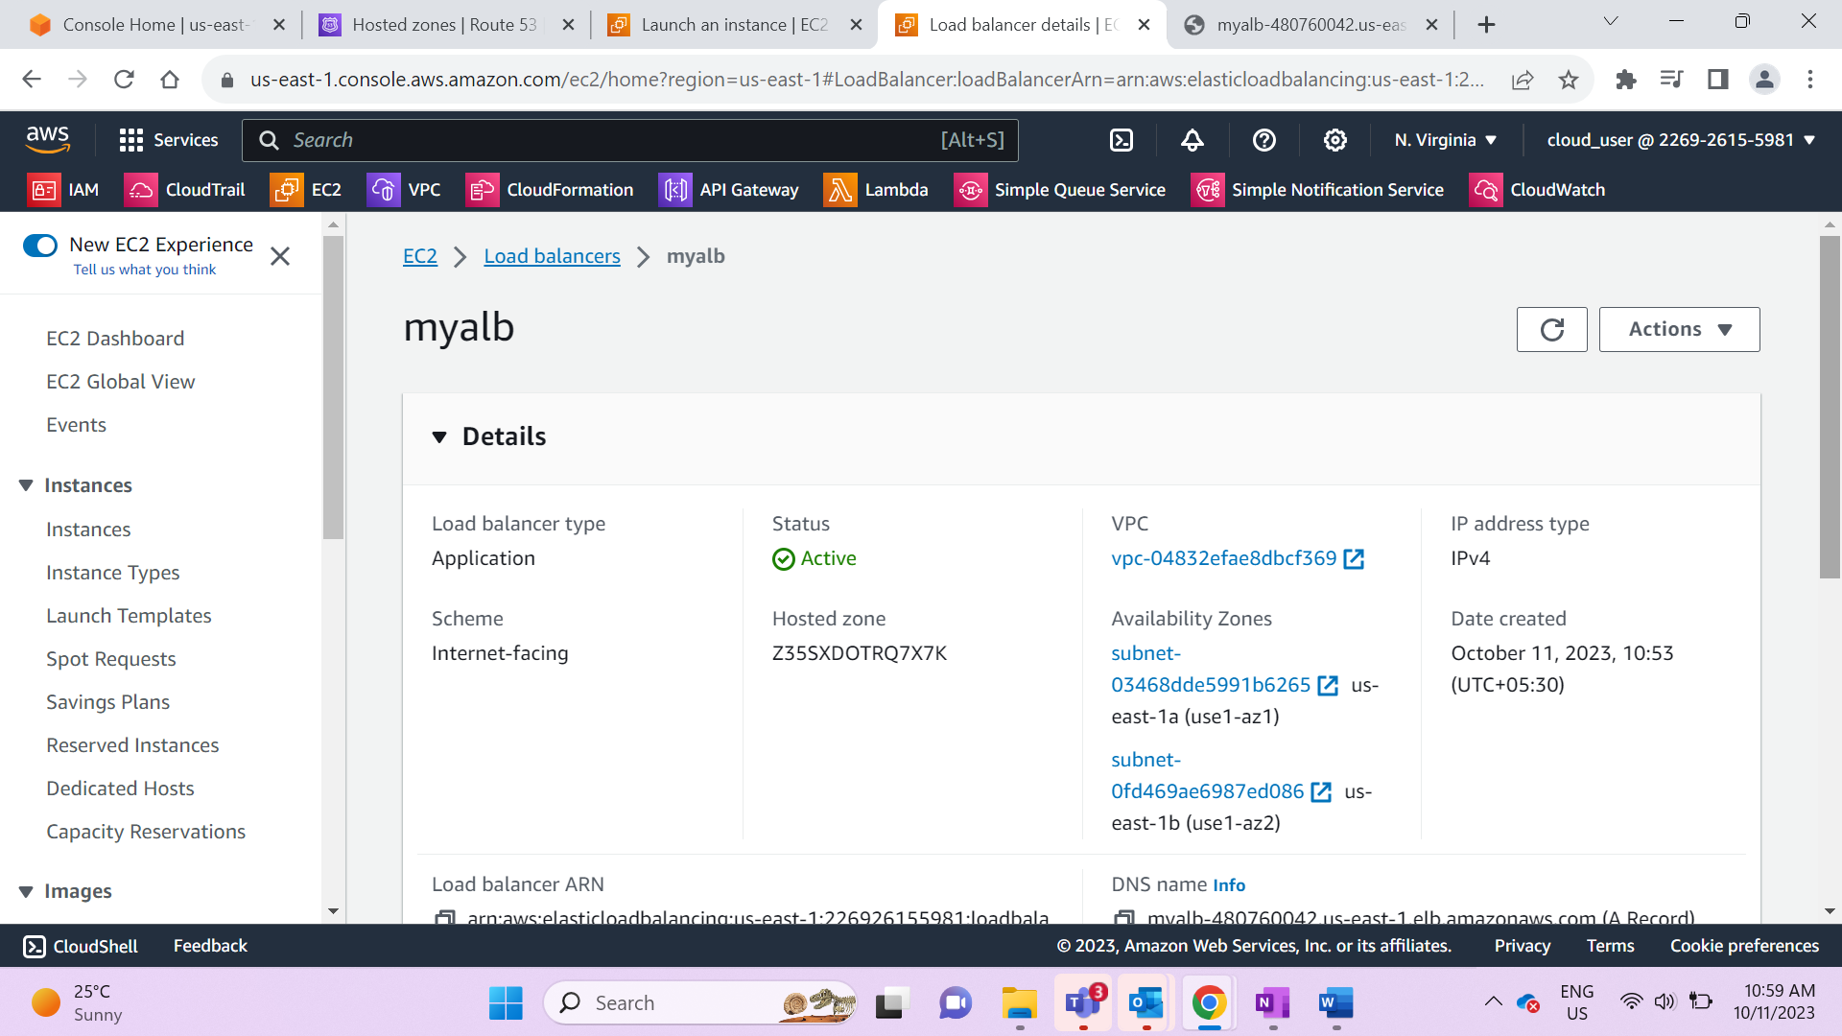

1. Configure Route 53 Alias

* Map a friendly domain name to application load balancer so we can access our website using our own domain name

Hosted zone acts as a container to all domain names

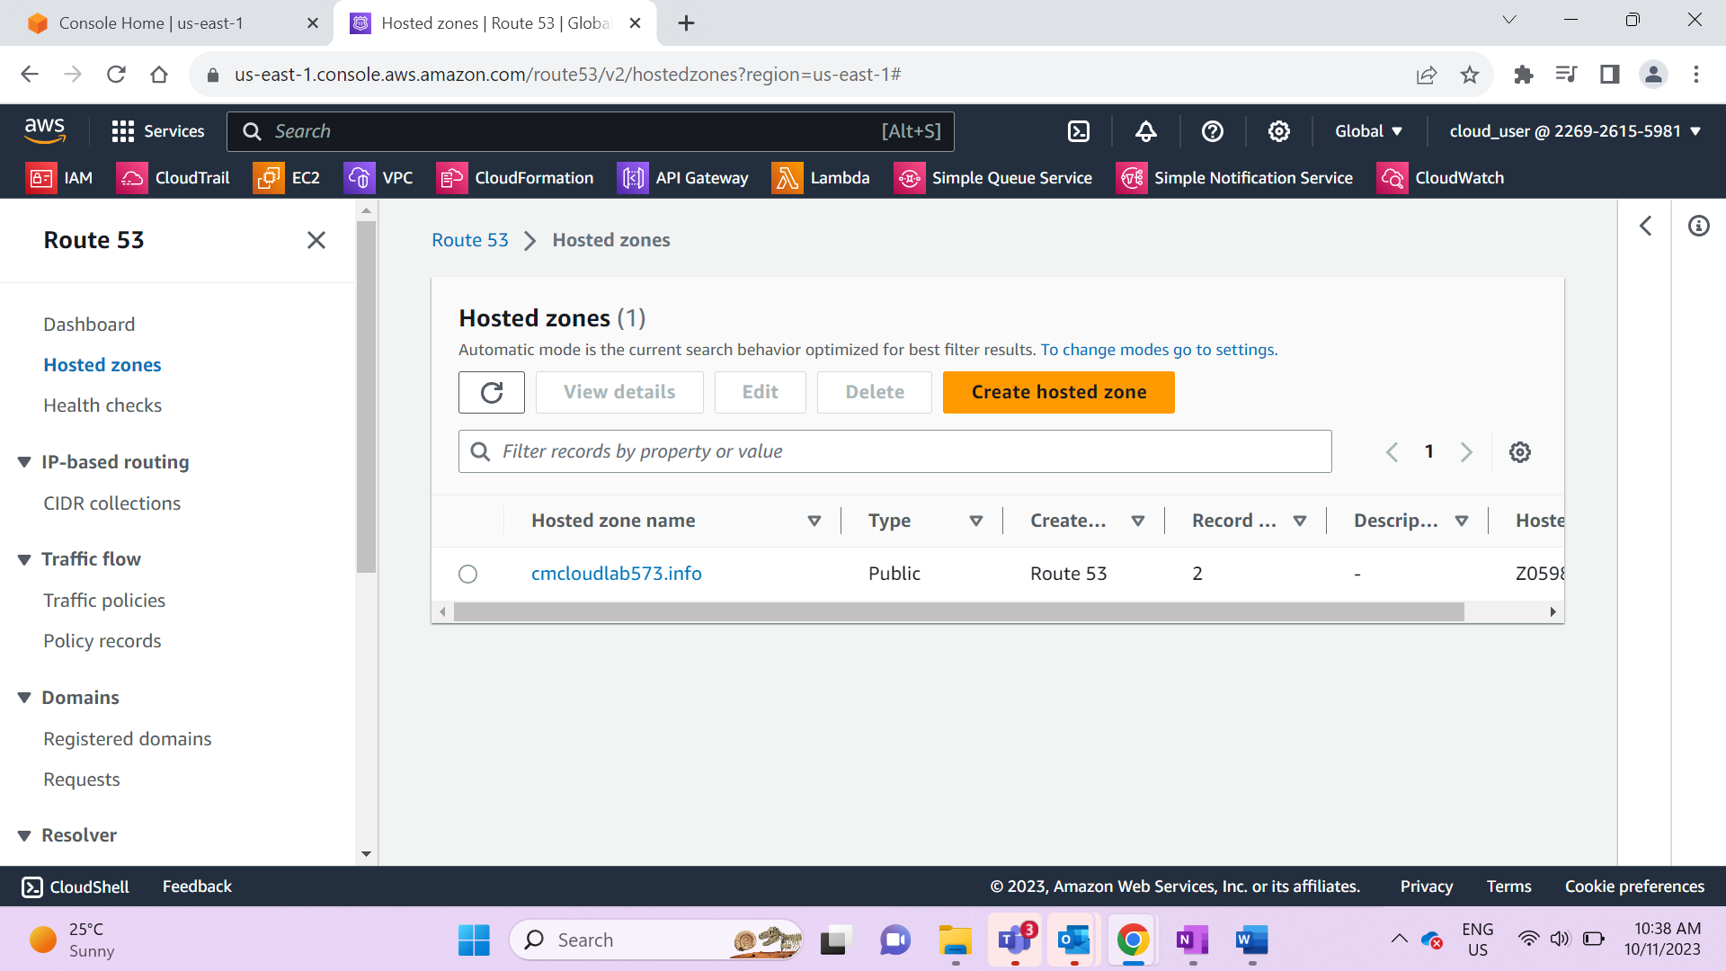

6. Open the DNS name link under ALB and see the following results.

This URL is not user friendly hence Route53 is used to create a user friendly URL to access website

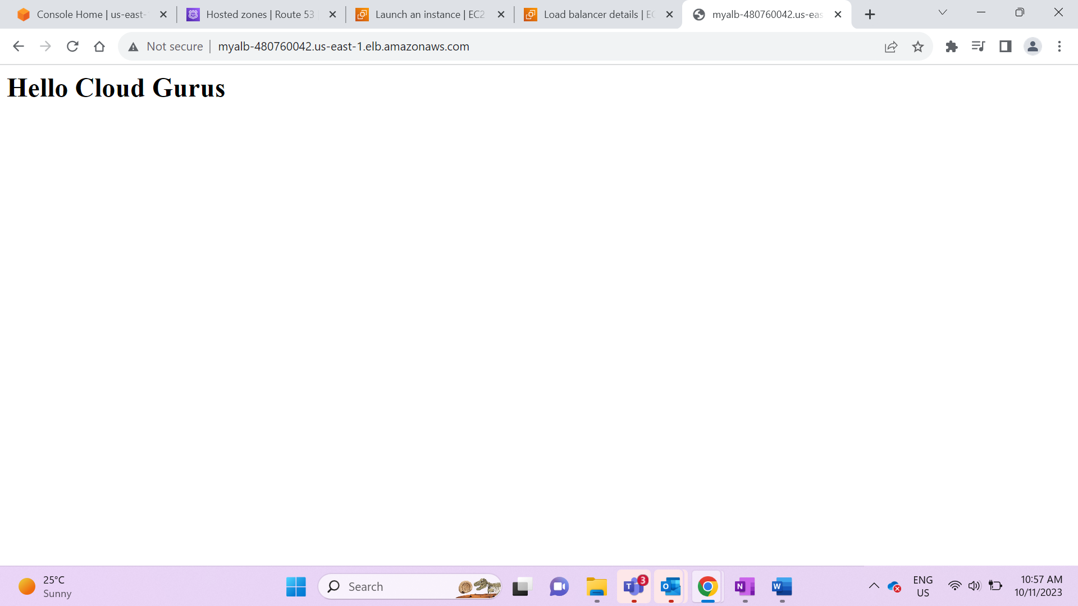

7. Go to hosted names and create record

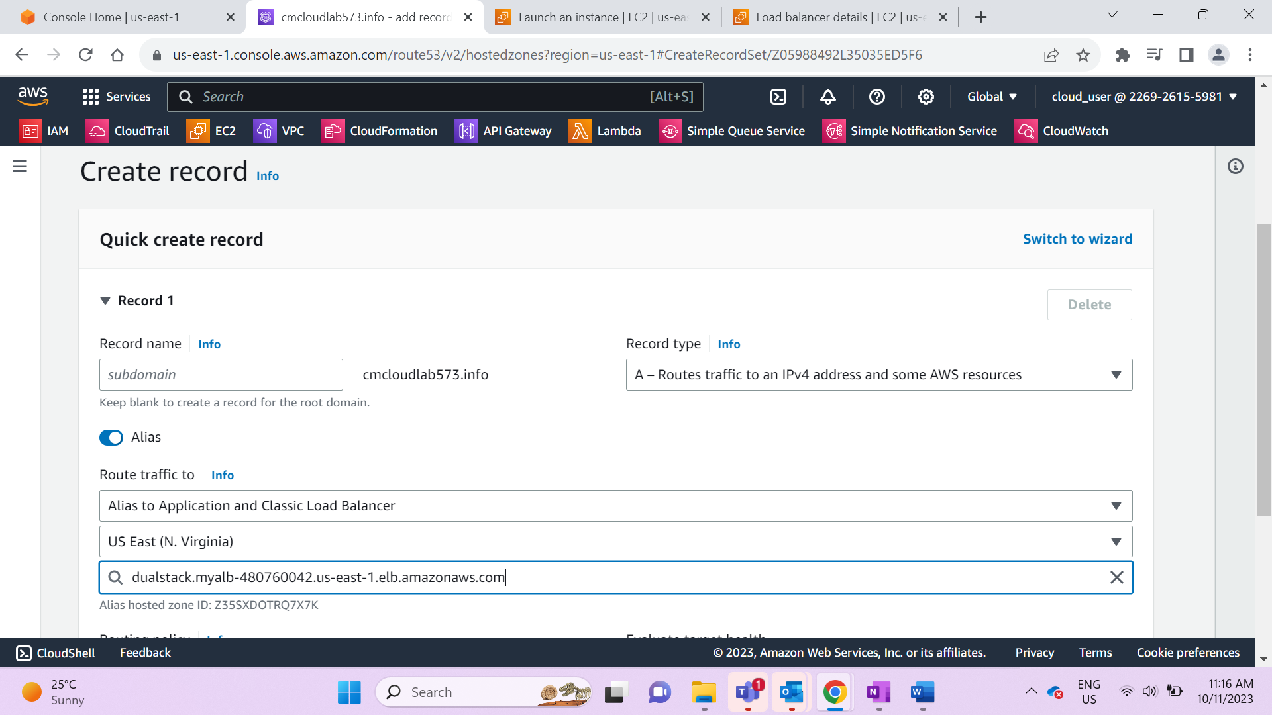

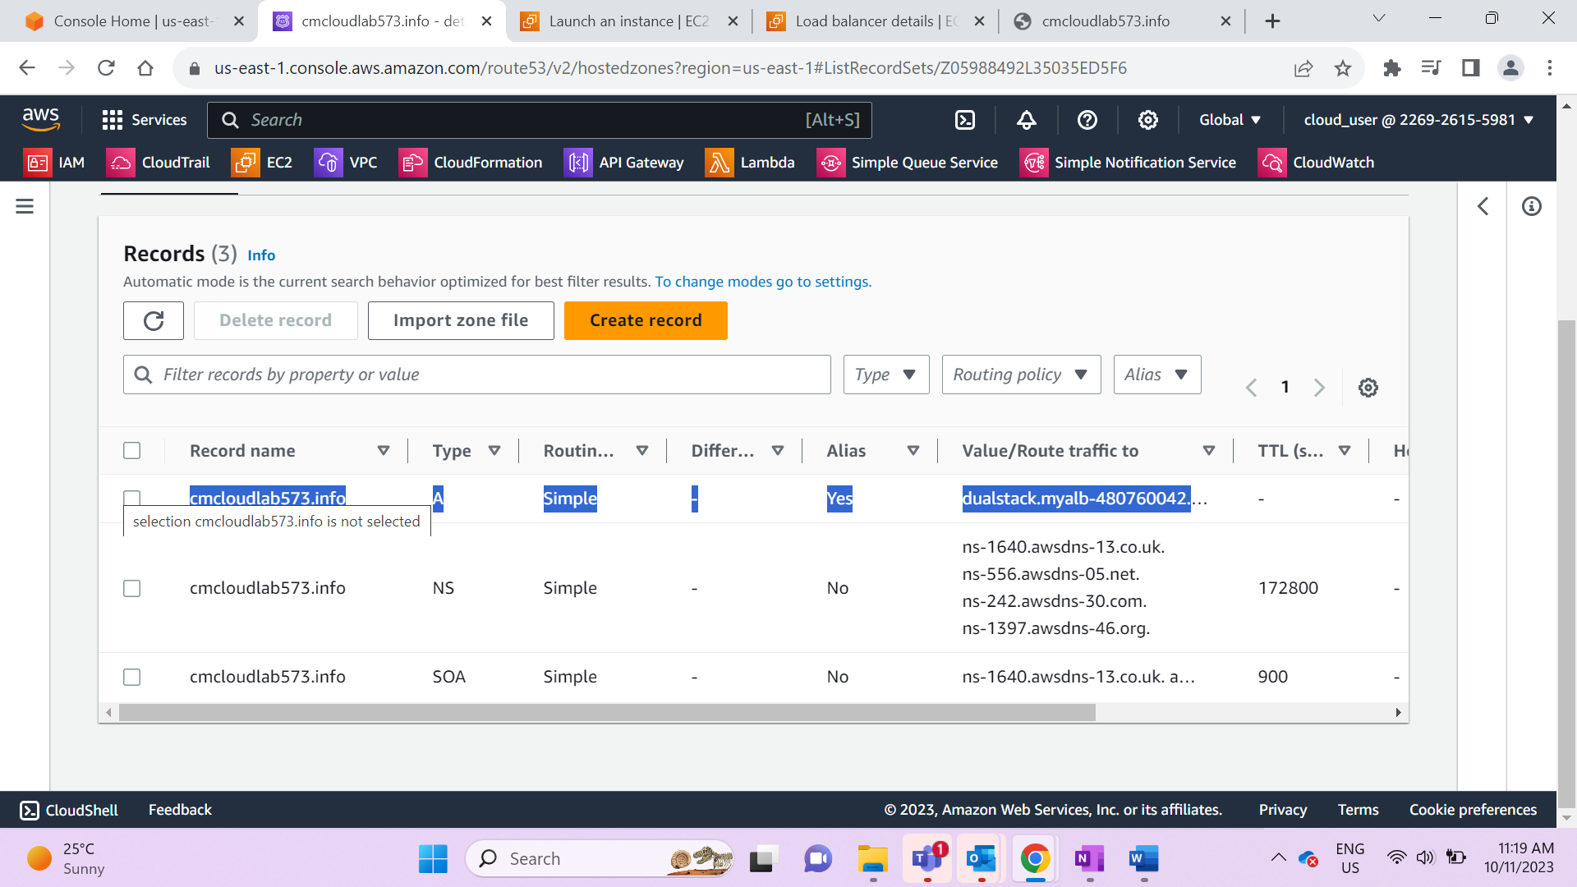

Copy the record name and open in new tab.

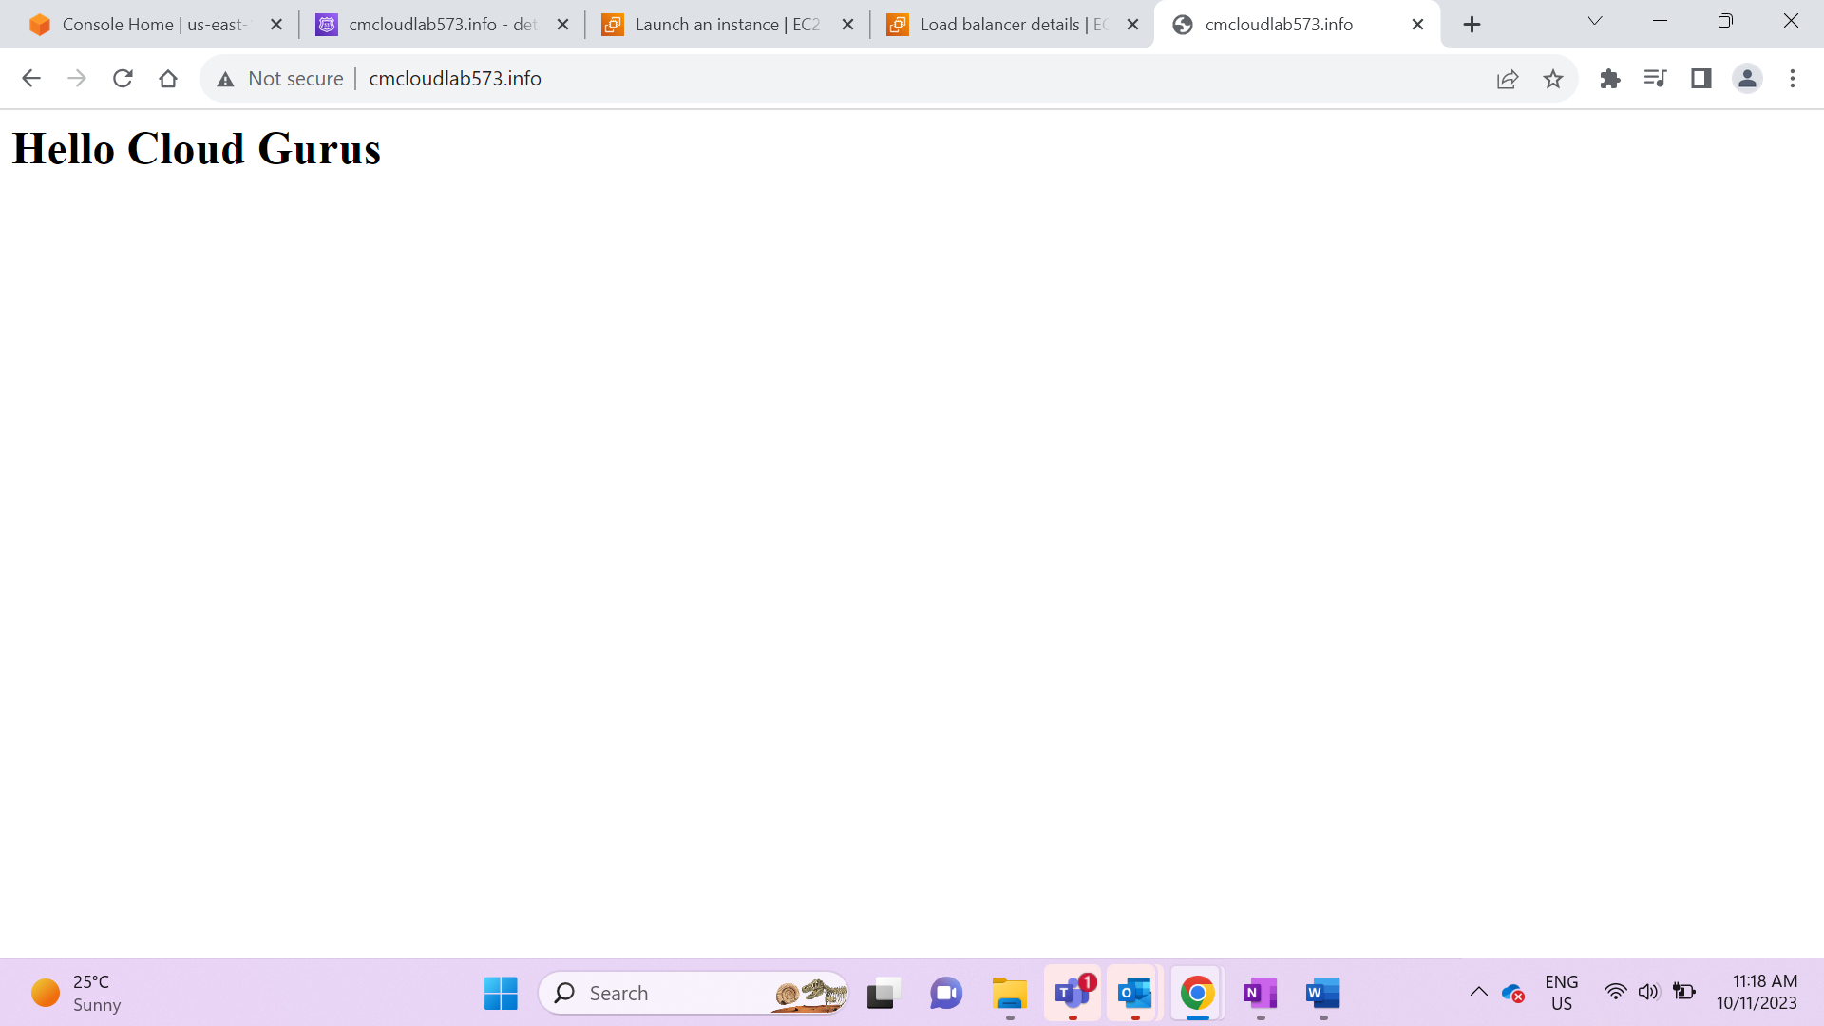

User data code:

#!/bin/bash

yum update -y

yum install httpd -y

echo "<html><body><h1>Hello Cloud Gurus</h1></body></html>" >/var/www/html/index.html

systemctl start httpd

systemctl enable httpd